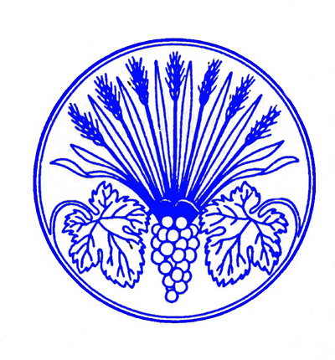
Les Dames d’Escoffier Chicago Chapter
Membership Nominating Form for CANDIDATE

The Chicago Chapter of Les Dames d’Escoffier International (LDEI) is dedicated to promoting women in the culinary arts and supporting educational and charitable activities. Since its founding in 1982, Les Dames d’Escoffier–Chicago has provided almost $1M in culinary scholarships to women and funding to a variety of community organizations and projects. Les Dames d’Escoffier International is comprised of 43 global chapters and membership is by invitation only.

Membership Criteria

All women proposed for membership:
- Are individuals of stature in the food, beverage or hospitality industries and have been actively employed in those industries for at least five years.
- Have made contributions through volunteer activities in the community.
- Are dedicated to furthering the role of women in the culinary professions.
- Will fulfill the expectations of membership, make a positive contribution to Les Dames d’Escoffier, agree to devote energy and time to the programs, work harmoniously with others, and actively support Les Dames d’Escoffier fundraising activities.

Attach a current resume or CV

Primary Sponsor:
Secondary Sponsor:
Your Name:
Professional Field:
Professional Position:
Number of Years in Profession:

Company:
Business Address:
Website:
Business Phone:
Cell Phone:
Email:
Home Address:
Home Phone:
(Please mark preferred contact information for Les Dames communication with an X)
List memberships in other relevant professional organizations:

Please list members of Les Dames d’Escoffier (Chicago or other chapters) other than your sponsors that you know or have worked with:

Member’s name | # of years you have known the member | How do you know them?

Please rank in order of preference the committees on which you would like to serve. All members are expected to serve on at least one committee. Number the below 1-5 with 1 being your preferred committee. (If you feel able to serve on more than one committee, you can have two #1 choices or more!)

___Events/Programs: This committee takes the lead on planning and executing all social networking and professional development events and programs.

___Scholarship and Giving: This committee processes the applications for all of our scholarship and business or career development giving.

___Communications: This committee works on internal communications such as our newsletter, website and correspondence with members, as well as PR, Marketing, and social media

___Fundraising: This committee works to find partners, sponsors and donors for our major fundraising efforts

___Green Tables: This committee works on our Green Tables initiatives including processing grant applications, planning and executing events related to agriculture, urban farming, sustainability, and environmental issues.

Why do you want to be a member of Les Dames d’Escoffier?

The undersigned declares that all above information is accurate and that you understand and will comply with the membership criteria as written, will adhere strictly to the code of ethics of Les Dames d’Escoffier, and will undertake to respect them in spirit as well as in content.

Members Code of Ethics
Members must maintain high professional and ethical standards and:
- Abide by the Bylaws of both LDEI and the Chicago Chapter.
- Avoid using the name LDEI and/or the Chicago Chapter in advertising, merchandising or promotion for personal advantage.
- Never allow the membership list of LDEI or the Chicago Chapter to be sold or used for merchandising, promotional purposes or commercial endorsement without the explicit approval of the Board.
- Sponsor for membership only those individuals known to have high ethical standards and professional stature in the area of food, beverages, nutrition, culinary history, and other fields related to the culinary industry.

Signature: ___________________________________________ Date: ______________________

